
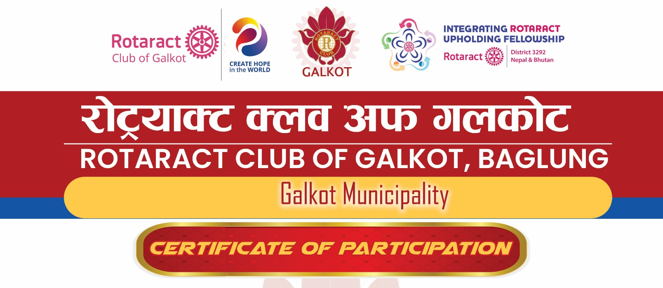

This certificate is presented to «Rtr» «Name» for «pp» active participation in the
1-day Club Officer Training Session (COTS).
#Club Officer Roles and Responsibilities
# Effective Communication within the Club
# Membership Growth and Retention
# Club Meeting Management
# Leadership and Team Building

Given this day, July 25, 2026, as a token of appreciation for your unwavering dedication to both personal and professional growth.
===================================
RTR. KAMAL KHAREL
President
Year 23/24

..............................
RTR. ANIL SHRESTHA
TRAINER
RY. 2026-27
..............................
RTR. LAXMI PUN
TRAINER
RY. 2026-27
..............................
RTR. NABIN CHALISE
PRESIDENT
RY. 2026-27

